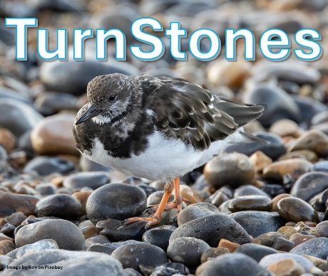 | TurnStones Newsletter no 1  Our newsletters are occasional updates on TurnStones;  an exploration of how conversations which interact with each other can lead each of us to new perspectives.  We are Jeremy Hinks and Marcos Frangos.  Read on. Enjoy. Join us!
What is TurnStones?
“TurnStones is amazing, so powerful and thought shifting.
I can highly recommend it, the shift it gave me was profound.”
Despite the popular wisdom behind ‘Start with Why’ it makes more sense for us to start with ‘What?’. TurnStones is a group activity based around a series of conversations which are co-created by the group, supported by Jeremy and Marcos. These conversations have the capacity to interact with each other in ways that are unique to each person involved. The interactions can lead to the turning over of current ideas and finding new perspectives from what you reveal.
Just like the action of the beautiful little waders called turnstones which gives them their name, you will turn over your own metaphorical stones to reveal something new. For the birds they find hidden food; for you it will be hidden ideas and feelings. Both nourishing, in different ways; an observation that speaks to the ‘why?’ of TurnStones as well!
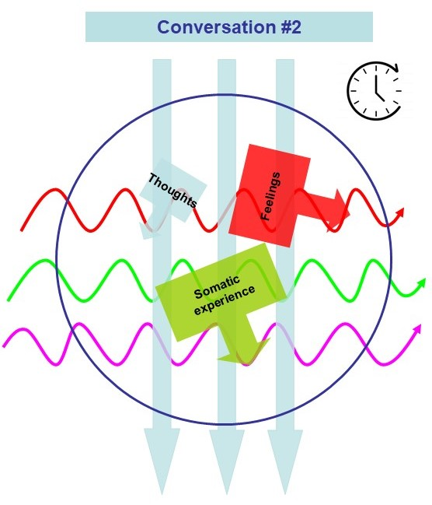
Imagine this. You come to a TurnStones session with something of interest to you. It will be composed of thoughts, emotions and bodily experience (see graphic). In the session, using a range of different approaches, Jeremy and Marco will facilitate a number of different conversations, prompted by language or imagery. The conversations have the capacity to interact with each other, and with the issue that you came to the session with. The nature of that interaction will be unique to you, arising from turning ‘stones’ at the level of your thinking and feeling. It is not a linear process, more associative - the making of connections. The nature of the connections will be influenced by experiencing TurnStones with others (their influence represented by the wavy lines) and they may form in real time or at some point in the future. TurnStones is a process with emergent outcomes, rather than outcomes where there is a strong relationship between cause and effect.
You can find out more by listening to Jeremy and Marcos talking about TurnStones
through this link.
Want to know more? | Reach out to Jeremy (Jeremy.d.hinks@gmail.com) or Marcos (marcos@kolimbri.com)
When and how? | Virtual connection with dates every two months at 1900 to 2030 (GMT) (currently 2024: 19/11; 2025: 21/01; 18/03; 20/05; 15/07)
Join us! | Go to our booking page through this link

